WELCOME TO
STAHL MENNONITE CHURCH
1201 Soap Hollow Rd, Johnstown, PA 15905

Pastor: Jayne Byler
Lay Leaders: Dave Miller, Joy Cotchen & Glenn Lehman

Pastor Cell Phone: (330) 224-3944
Church Phone: (814) 288-5523
E-Mail: stahlmennonite@gmail.com
*******************************************************
March 31, 2019

SUNDAY SCHOOL – 9:30 A.M.
Uniform Series – Upstairs Sunday School Class
Bible Study – Basement Kitchen Class
MORNING WORSHIP – 10:30 A.M.
Lent 4: Blessed Hunger, Holy Feast:
God reaches out with open arms

Worship Leader: Sonya Horsley
Song Leader: Leah Rittenhouse
Welcome & Announcements
Lighting the Peace Lamp
Gathering Song
Call to Worship: (based on Psalms 63 and 32)
Leader: O God, you are our God. We seek you.
People: Our souls thirst for you as in a dry and weary
land where there is no water.
Leader: We confess our sin to you, and you forgive us.
People: We offer our prayers to you, and you embrace us.

ALL: O God, you satisfy our souls as with a rich feast.
In the shadow of your wings, we sing for joy,
and you uphold us.
Prayer
Offering/Hymn
Extinguishing Candle: Jayne
Song: “All this pain" – new song from Voices Together
(in back of HWB)
Sharing Our Joys and Concerns: “God of Love, Hear our Prayer”
Scripture: Luke 15:1-3, 11b-32 – Chris Lehman
Message: "One Story, Three Perspectives" – Jayne
Response of Confession and Reconciliation:
Leader: (reading Psalm 32:10-11)
“Many are the torments of the wicked,
but steadfast love surrounds those who trust
in the Lord.
Be glad in the Lord and rejoice, O righteous,
and shout for joy, all you upright in heart.”
Who will trust the Lord today?
Confessional Response: Donna Thomas
I will trust the Lord today.
Leader: We are all invited to trust the Lord today.
Let us bring ourselves to God in prayer.
ALL: God of steadfast love, we put our trust in your
care for us.
When we need to find our way home, we put our
trust in you.
Leader: When we need forgiveness (pause),
we put our trust in you.
When our souls hunger for a new way of living (pause),
we put our trust in you.
ALL: In the morning and in the evening,
we will put our trust in you.
Leader: Our generous God provides for us.
Sending Song
Benediction: (from 2 Corinthians 5)
In Christ there is a new creation.
Everything old is gone, all is new.
Go forth, embodying the ministry of reconciliation given
to us by Christ.
Greeters for April: Neil & Ellen Lehman
Bulletin Editor for April: Shana Lichtenfels – 288-0171
Front Table Arrangement for April: Worship Committee
Church Sign for April: Neil & Ellen Lehman
Offering Holders for April: Neil & Ellen Lehman
St. Francis Sharing & Caring Item for April: Toilet Paper
Offering: 03/24/2019 - $1,247.00 – Regular
20.00 – LaHash
$1,267.00 = TOTAL
*******************COMING EVENTS*******************
Wed., Apr. 3, 7:00 p.m. – Church Council
Sun., Apr. 7, 5:00 p.m. – Stahl's Annual Spring Banquet (see notes)
Mon., Apr. 8 – Thurs., Apr. 11 – Allegheny Mennonite Conference
Pastor's Bible Study (Jayne & Joy attending)
Sun., Apr. 14, 2:00 p.m. – Kids Connection Easter Egg Hunt
Mon., Apr. 15, 7:00 p.m. – Hosting EMHS Choir program
Fri., Apr. 19, 7:00 p.m. – Good Friday Service
Sun., Apr. 21, 8:45 a.m. – Easter “Sonrise” Service
9:30 a.m. – Easter Breakfast
10:30 a.m. – Easter Worship
Wed., May 8, 7:15 p.m. – Spiritual Growth Group
Thu., May 9, 2:30 p.m. – Lay Leaders
Fri., May 10, 9:00 a.m. – Worship Committee
Sun., July 28 to Thurs., Aug. 1 – Summer Bible School with Thomas Mennonite Church
Sat. & Sun., Sept. 28-29 – Church Retreat at Laurelville
**************NOTES & ANNOUNCEMENTS**************
Happy Birthday: Wish the following a Happy Birthday today or send them a card this week: Wed., April 3 – Grant Cotchen

Jayne will be in the office this week on Tuesday and Friday and will be off Monday and Thursday. She is always available via cell in case of an emergency! (330) 224-3944)

Anyone wishing to order lilies for the Easter Season to be used in church, can contact Joyce Telenko by Sunday, April 1st, either at church or by calling 479-7092. The cost this year will be $9.00.

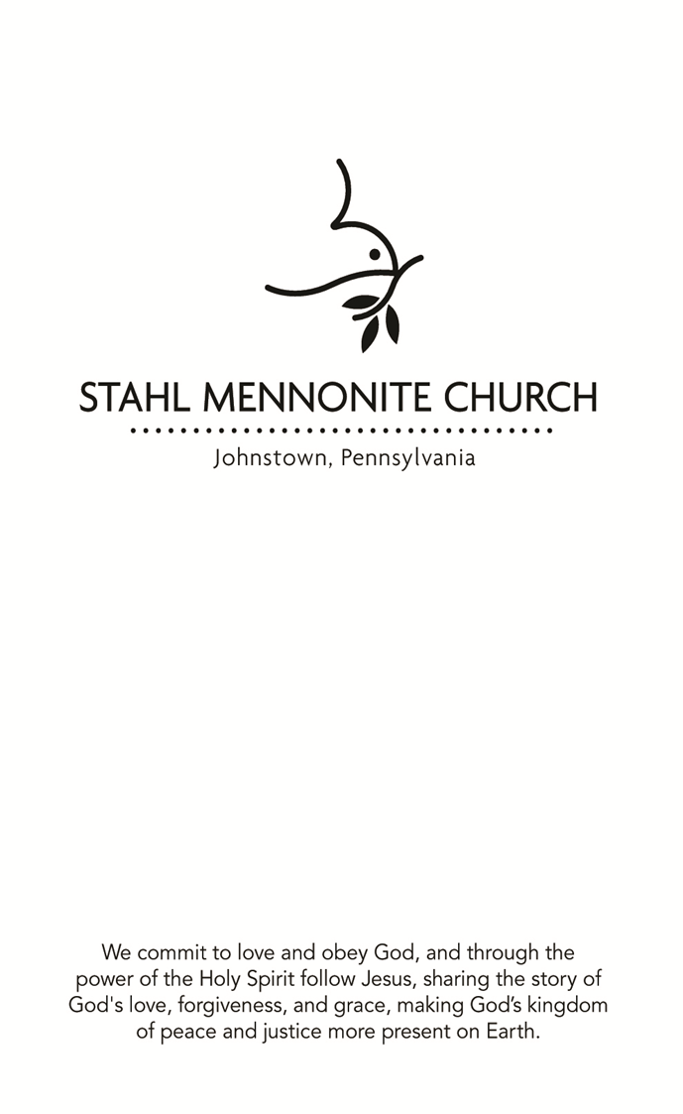
March 31, 2019

FOCUS STATEMENT: When we are lost and far from God,
God reaches out with open arms. We get up and enter
the feast of reconciliation.

The art piece up front is the compilation of the smaller works done by members of the congregation as each has committed themselves to use their gifts for the work of Stahl Mennonite Church in the coming year. Joined together we form the beautifully diverse body of Christ. A guide to what each color symbolizes is near the piece. If you would like to join your “square” to the work, talk to Jayne. There is always room for more!

Sun., April 7 at 5:00 p.m. – It’s that time again to celebrate with our Annual Spring Banquet. We will meet at the church at 5:00 p.m. to carpool. The cost is $20 per person. If the cost will prohibit you from coming, please see Joy. Sign-up sheet on the bulletin board.

Johnstown Christian School students will be presenting James and the Giant Peach at 7:00 p.m. on April 11, 12 and 13, in the JCS gymnasium. Cost is $7 Adults & $4 Students/Children. There will be a dinner theater on April 12 at 5:30 (advanced ticket required; cost is $15; available in the JCS office). A Children's Matinee will be performed at 2:00 p.m. on April 13
(1 free Child ticket with the purchase of 1 Adult ticket). All tickets will be sold at the door except for the dinner theater. (814) 288-2588

The Easter Egg Hunt will be held on April 14 at 2:00 p.m. at the church.
Please let Cathy Miller know if your child (through grade 3) is attending at (814) 254-2634.

Stahl Church will host Eastern Mennonite High School Touring Choir for a program on Monday, April 15, 7:00 p.m. We are looking for persons who can help to provide lodging for approximately 45 persons for Monday night and provide transportation to Stahl on Tuesday morning. If you can house two or more students or one of the directors or bus drivers, please contact Jeanette Hunsberger at (814) 483-9332.

Community Good Friday services on April 19, 2019 will be held at the Tire Hill Church of the Brethren from 12:00 noon until 3:00 p.m. Pastor Brian Simmons is in charge of this service. If your schedule permits, please try to attend this service to not only support the Conemaugh Township Area Ministries, but to also be reminded of the Passion and Love of this Season.

Because of overlapping scheduled events, the Spiritual Growth Group will NOT meet in April. Next meeting time will be May 8 at 7:15 p.m.

Is there such a thing as a Mennonite song? Read a series of reflections from committee members of the Voices Together new hymnal project on the Menno Snapshots blog: mennoniteusa.org/tag/voices-together

ATTENTION: We want everyone in the congregation to be able to communicate with our media group by using their new email address. The new address is: stahlmennonitemedia@gmail.com. Please add this to your contact list! This will help get any requests to the media group no matter who is scheduled to run sound on any particular day. Also, if you are able to send requests before the service, it would aid in the preparation process. Any questions, please ask Bill Horsley.

The vision of Allegheny Mennonite Conference (AMC) of which our congregation is a member, is to be Jesus-centered, collaborative and committed to place-based ministry. AMC seeks to preserve and grow significant ministries to pastors, congregations, children and youth which are the history and hallmark of the Conference. AMC has been faithfully allocating its financial resources wisely to close the funding gap created by having fewer congregations now than in the past. In your mailbox is a prayer card for AMC which tells more. AMC’s goal of a balanced budget while maintaining its current level of staffing can only be accomplished by additional contributions from individuals and businesses beyond AMC’s pledged income from its member congregations. Please pray as the Lord leads you for AMC and consider a one-time gift or an ongoing level of giving to help AMC further healthy unity in the midst of Christ-centered diversity (Eph. 4:11-13). Giving information is on the prayer card, or can be designated through our Sunday morning offerings by noting this on the memo line of your check. Thank You!

Mission Note: Today, Mennonite Mission Network’s Service Adventure units from Albuquerque, New Mexico; Anchorage, Alaska; Colorado Springs, Colorado; Jackson, Mississippi; and Johnstown, Pennsylvania; are beginning a week of team-building and service with Mennonite Disaster Service in Bloomington, Texas. Pray for God’s love to flow through them.
*****************PRAYER REQUESTS******************
Travelers Curt Lichtenfels Dwight Gindlesperger
Jane Miller Ron Telenko, Sr. Leah's friend
Dave Gates Dan Ross Family Jacob Horsley
Ethan Kelly Unspoken Requests Pittsburgh Community Larry & Anne Marie Millender

