WELCOME TO
STAHL MENNONITE CHURCH
1201 Soap Hollow Rd, Johnstown, PA 15905

Pastor: Jayne Byler
Lay Leaders: Dave Miller, Joy Cotchen & Glenn Lehman

Pastor Cell Phone: (330) 224-3944
Church Phone: (814) 288-5523
E-Mail: stahlmennonite@gmail.com
*******************************************************
April 7, 2019

SUNDAY SCHOOL – 9:30 A.M.
Uniform Series – Upstairs Sunday School Class
Bible Study – Basement Kitchen Class
MORNING WORSHIP – 10:30 A.M.
Lent 4: Blessed Hunger, Holy Feast:
God makes a way

Worship Leader: Neil Lehman Song Leader: Leah Rittenhouse

Welcome & Announcements
Lighting the Peace Lamp
Gathering Song
Call to Worship: (based on Psalms 63 and 126)
Leader: O God, you are our God. We seek you.
People: Our souls’ thirst for you as in a dry and weary land
where there is no water.
Leader: The Lord does great things for us, and we rejoice!
People: The Lord restores our fortunes, and we shout for joy.
All: O God, you satisfy our souls as with a rich feast.
In the shadow of your wings, we sing for joy, and
you uphold us.
Prayer
Offering/Hymn
Extinguishing Candle
Song: “All this pain" – new song from Voices Together
(in back of HWB)
Sharing Our Joys and Concerns: “God of Love, Hear our Prayer”
Scripture: Matthew 14:13-21; 15:21-38 – Rod Lehman
Message: “Bread, Not Crumbs or Stones” - Rebecca Barrett-Fox
Response of Confession and Reconciliation:
Leader: (reading Isaiah 43:17-21)
“Do not remember the former things, or consider
the things of old.
I am about to do a new thing; now it springs forth,
do you not perceive it?
I will make a way in the wilderness and rivers in
the desert.
The wild animals will honor me, the jackals and
the ostriches;
for I give water in the wilderness, rivers in the
desert, to give drink to my chosen people,
the people whom I formed for myself so that
they might declare my praise.”
Who will see the new work of God?
Confessional Response: Carol McKool
I will see the new work of God.
Leader: We are all invited to see the new work of God.
Let us bring ourselves to God in prayer.
All: God of hope, give us eyes to see the new work you
are doing among us.
When we struggle to discern what lies ahead,
we will see the new work of God.
Leader: When our circumstances appear to hold no hope
(pause), we will see the new work of God.
When our souls’ hunger for your presence (pause),
we will see the new work of God.
All: In the morning and in the evening, we will see the
new work of God.
Leader: Our generous God provides for us.
Sending Song
Benediction: (from Philippians 3)

Greeters for April: Neil & Ellen Lehman
Bulletin Editor for April: Shana Lichtenfels – 288-0171
Front Table Arrangement for April: Worship Committee
Church Sign for April: Neil & Ellen Lehman
Offering Holders for April: Neil & Ellen Lehman
St. Francis Sharing & Caring Item for April: Toilet Paper
Offering: 03/31/2019 - $2,310.00 – Regular
406.00 – MCC
$2,716.00 = TOTAL
*******************COMING EVENTS*******************
Sun., Apr. 7, 5:00 p.m. – Stahl's Annual Spring Banquet
Mon., Apr. 8 – Thurs., Apr. 11 – Allegheny Mennonite Conference
Pastor's Bible Study (Jayne & Joy attending)
Sun., Apr. 14, 2:00 p.m. – Kids Connection Easter Egg Hunt
Mon., Apr. 15, 7:00 p.m. – Hosting EMHS Choir program
Fri., Apr. 19, 7:00 p.m. – Good Friday Service
Sun., Apr. 21, 8:45 a.m. – Easter “Sonrise” Service
9:30 a.m. – Easter Breakfast
10:30 a.m. – Easter Worship
Sun, Apr 28 – Mission Offering for Benevolence Fund
Wed., May 8, 7:15 p.m. – Spiritual Growth Group
Thu., May 9, 2:30 p.m. – Lay Leaders
Fri., May 10, 9:00 a.m. – Worship Committee
Sun., July 28 to Thurs., Aug. 1 – Summer Bible School with Thomas Mennonite Church
Sat. & Sun., Sept. 28-29 – Church Retreat at Laurelville
**************NOTES & ANNOUNCEMENTS**************
Happy Birthday: Wish the following a Happy Birthday today or send them a card this week: Wed., April 10 – Shaun Smith; Thurs., April 11 – Jonathan Shetler

Welcome to Rebecca Barrett Fox Barrett Fox, our guest speaker this morning. Rebecca will be the resource person for the Allegheny Conference Pastor’s Bible Study beginning tomorrow. She is also Sarah Barrett’s sister! She is here all the way from Utah and we are fortunate to have gotten her to fit this morning into her busy schedule while in the east.

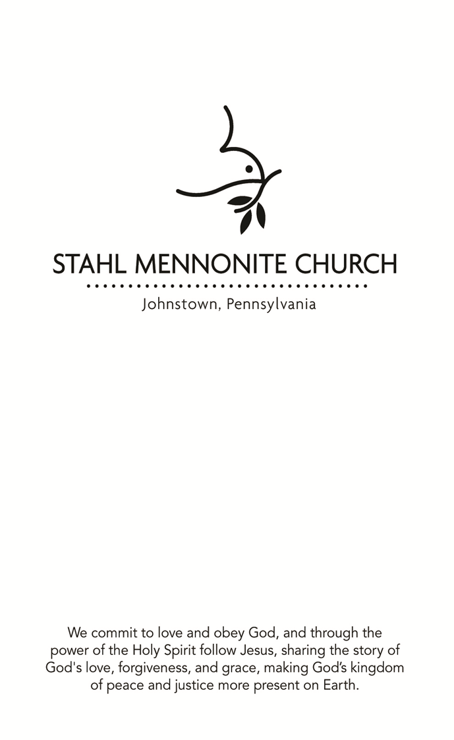
March 31, 2019

FOCUS STATEMENT: When we are exhausted, God makes a way through what seems impossible. We move forward in hope as God does a new thing.

Jayne will be in the office this week on Friday. She will be at the AMC Pastor’s Spring Bible Study at Laurelville Mon through Thu, Apr 8-11. She is available via cell in case of an emergency!
(330-224-3944)

In your mailboxes is a copy of the recently approved guidelines for the congregational Benevolence Fund. Our April Mission offering will be to help build this fund in order to be available to those in the congregation who experience various needs.

The family of Beulah Hershberger would like you to know that she will be 102 years old on April 13. Her address is 2000 Cambridge Dr. Rm 501, Davidsville PA 15928, if you would like to send her a card.

Johnstown Christian School students will be presenting James and the Giant Peach at 7:00 p.m. on April 11, 12 and 13, in the JCS gymnasium. Cost is $7 Adults & $4 Students/Children. There will be a dinner theater on April 12 at 5:30 (advanced ticket required; cost is $15; available in the JCS office). A Children's Matinee will be performed at 2:00 p.m. on April 13
(1 free Child ticket with the purchase of 1 Adult ticket). All tickets will be sold at the door except for the dinner theater. (814) 288-2588

The Easter Egg Hunt will be held on April 14 at 2:00 p.m. at the church. Please let Cathy Miller know if your child (through grade 3) is attending at (814) 254-2634.

Stahl Mennonite Church will host the EMHS Touring Choir on Monday, April 15, 7 PM. We are still looking for hosts for 25 persons overnight on Monday, after the concert. Students are paired. If you can only house one person you might consider the bus driver, director or adult chaperones who will also be traveling. Please contact Jeanette Hunsberger 814-483-9332 if you are able to help in this way. Thank You!!

Because of overlapping scheduled events, the Spiritual Growth Group will NOT meet in April. Next meeting time will be May 8 at 7:15 p.m.

Community Good Friday services on April 19, 2019 will be held at the Tire Hill Church of the Brethren from 12:00 noon until 3:00 p.m. Pastor Brian Simmons is in charge of this service. If your schedule permits, please try to attend this service to not only support the Conemaugh Township Area Ministries, but to also be reminded of the Passion and Love of this Season.

ATTENTION: We want everyone in the congregation to be able to communicate with our media group by using their new email address. The new address is: stahlmennonitemedia@gmail.com. Please add this to your contact list! This will help get any requests to the media group no matter who is scheduled to run sound on any particular day. Also, if you are able to send requests before the service, it would aid in the preparation process. Any questions, please ask Bill Horsley.

Paul and Serena Manickam of Mennonite Mission Network have been working with the Mennonite churches in the area around Iquitos, Peru. Recently, their request for visa renewal was denied. Pray for God’s comfort and guidance as they discern next steps.

*****************PRAYER REQUESTS******************
Travelers Nichelle Barr Dwight Gindlesperger
Jane Miller Ron Telenko, Sr. Leah's friend
Dave Gates Barb Lashinsky Dan Blough
Jenn Petro Unspoken Requests Pittsburgh Community Larry & Anne Marie Millender John & Megan Bayush
Jim Bonovitz Quenna Smith

