WELCOME TO
STAHL MENNONITE CHURCH
1201 Soap Hollow Rd, Johnstown, PA 15905

Pastor: Jayne Byler
Lay Leaders: Dave Miller, Joy Cotchen & Glenn Lehman

Pastor Cell Phone: (330) 224-3944
Church Phone: (814) 288-5523
E-Mail: stahlmennonite@gmail.com
*******************************************************
June 30, 2019

SUNDAY SCHOOL – 9:30 A.M.
Uniform Series – Upstairs Sunday School Class
Bible Study – Basement Kitchen Class

MORNING WORSHIP – 10:30 A.M.
Worship Leader: Ron Telenko
Song Leader: Jeannette Hunsberger

THEME: "Come to the Welcome Table: A Place of Salvation"

Welcome & Announcements
Lighting the Peace Lamp
Invitation
Gathering Song
Call to Worship
Leader: We bid you welcome
who come with weary spirit seeking rest.
All: Who come with troubles that are too much with you,
who come hurt and afraid

Leader: We bid you welcome who come with hope in your heart.
All: Who come with anticipation in your step,
who come proud and joyous.

Leader: We bid you welcome who are seekers of new faith.
All: Who come to probe and explore,
who come to learn.

Leader: We bid you welcome who enter this place as a
homecoming.
All: Who have found here room for your spirit,
who find in this people a home.

Leader: Whoever you are,
whatever you are,
wherever you are on your journey,
we bid you welcome.

Prayer
Offering
Song of Gratitude and Praise
Sharing Our Joys and Concerns: “God of Love, Hear our Prayer”
Scripture: Luke 7:36-50 – A Sinful Woman at the Table
(Glenn Lehman)
Message: “Generous Love” – Jayne
Response: “A Revolution in Faith” by Lisa Frenz
Sending Song
Sending Words

******************************************************

Greeters for July: Myles and Sharon Shetler
Bulletin Editor for July: Ellen Lehman
Front Table Arrangement for July: Sharon Shetler
Church Sign for July: Sonya Horsley
Offering Holders for July: Myles and Sharon Shetler
St. Francis Sharing & Caring Item for June: Toilet Paper
Offering: 06/23/2019 $1,122.00 – Regular
150.00 – Training for Jayne
$1,272.00

*******************COMING EVENTS*******************
Today, Sun., June 30 – Mission Offering for New Day Camp
Tues.–Sat., July 2–6 – MennoCon19 in Kansas City, MO
Wed. July 17 – Provide packed lunch for New Day Camp
Fri., July 19, 9:00 a.m. – Worship Committee
Fri.-Sat., July 19-20 – TriState MCC Relief Sale
July 28 – Youth Stockholders Lunch
Sun., July 28 to Thurs., Aug. 1 – Summer Bible School with
Thomas Mennonite Church
Fri.–Sun., Aug. 2-4 – AMC Summer Celebration of Congregations
Sat.–Sun., Sept. 28-29 – Church Retreat at Laurelville

**************NOTES & ANNOUNCEMENTS**************
Happy Birthday: Wish the following a Happy Birthday today or send them a card this week: Today, July 1 – Lindsey Lehman; Fri., July 5 – Abigail Shetler

Happy Anniversary: Wish the following a Happy Anniversary today or send them a card this week: Fri., July 1 – Paul & Ruth Thomas

Jayne will be out of the office all week because she will be attending MennoCon 19 in Kansas City. In case of an emergency contact one of the Lay Leaders, (Dave Miller or Glenn Lehman. Joy Cotchen will also be in Kansas City)

Pray this week for people of all ages attending MennoCon19, the July 2-6 MC USA convention in Kansas City, Missouri, that those attending may fellowship together, learn from one another, encounter God's love and be transformed. From our congregation Jacob Horsley, Darden Horsley, Ryan Kaltreider, Devin Cable, Joy Cotchen and Jayne Byler will be attending.

Our Mission Offering today will go to New Day Inc.
Something New for Children: Under the table with the bulletins in the foyer are Activity Bags for the kids. Feel free to take one and use it during worship then return it before you head home. If you have ideas of something else you would like in them, let Jayne or Sharon Shetler know!

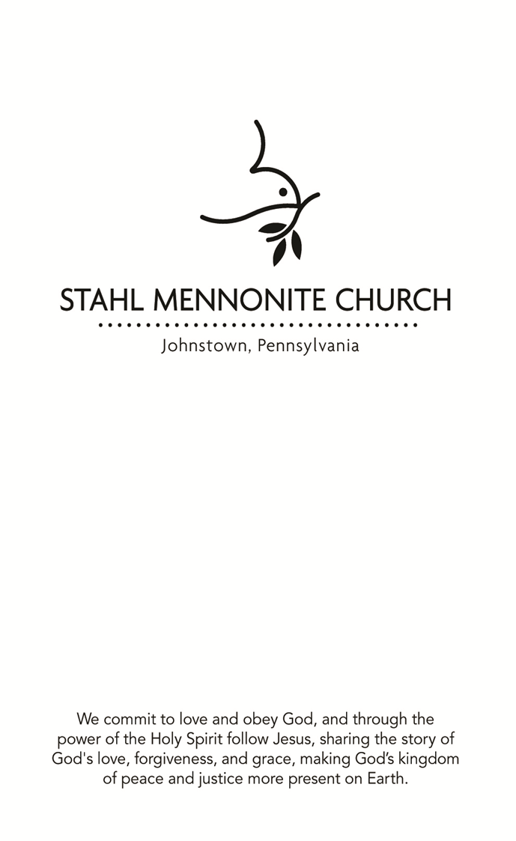

Jayne has the opportunity to attend a leader training for "Oriented to Love". This training would help her gain skills to facilitate conversations around difficult issues, particularly related to LGBTQ perspectives. For more information go to “Oriented to Love Dialogue Facilitator Training”. Lay Leaders are recommending she attend this training; however, it will mean a cost of $500 above what has been budgeted for professional expenses. If you would like to contribute to this opportunity, you can designate an above budget donation in the regular offering, designated OTL training for Jayne. Thanks!

MYF Stock Sales: Last chance to purchase! Would you like to make the investment of a lifetime? Now is the time to invest in the nurture of the Stahl Church Youth as they plan to attend MennoCon 19 in Kansas City with thousands of other Mennonite Youth from across the country. Cost of the stock is $20. per share and you can purchase as many shares as you would like. The dividend will be in knowing that you invested in the life of the youth from our congregation as well as a Stockholder’s Luncheon on July 28, where you can experience in Kansas City through stories from the youth. Forms are at the mailboxes or talk to any of the youth or Jen Kaltreider or Sonya Horsley. Thanks for your investment.

You're invited to support Mennonite Central Committee (MCC) at the TriState Relief Sale on July 19-20 at the Garrett County Fairgrounds (270 Mosser Rd. McHenry, MD 21541). Enjoy barbeque chicken, horse-drawn carriage rides and more while supporting the international ministries of MCC! For more information, visit mcc.org/events or contact Yvonne Devers at (812) 421-9008 or email bldevers@atlanticbb.net.

Jayne has the opportunity to attend a leader training for "Oriented to Love". This training would help her gain skills to facilitate conversations around difficult issues, particularly related
to LGBTQ perspectives. For more information go to “Oriented to Love Dialogue Facilitator Training”. Lay Leaders are
recommending she attend this training; however, it will mean a
cost of $500 above what has been budgeted for professional
expenses. If you would like to contribute to this opportunity, you
can designate an above budget donation in the regular offering, designated OTL training for Jayne. Thanks!

MYF Stock Sales: Last chance to purchase! Would you like to make the investment of a lifetime? Now is the time to invest in
the nurture of the Stahl Church Youth as they plan to attend MennoCon 19 in Kansas City with thousands of other Mennonite Youth from across the country. Cost of the stock is $20. per share and you can purchase as many shares as you would like. The dividend will be in knowing that you invested in the life of the
youth from our congregation as well as a Stockholder’s Luncheon on July 28, where you can experience in Kansas City through stories from the youth. Forms are at the mailboxes or talk to any of the
youth or Jen Kaltreider or Sonya Horsley. Thanks for your investment.

You're invited to support Mennonite Central Committee (MCC) at
the TriState Relief Sale on July 19-20 at the Garrett County Fairgrounds (270 Mosser Rd. McHenry, MD 21541). Enjoy
barbeque chicken, horse-drawn carriage rides and more while supporting the international ministries of MCC! For more information, visit mcc.org/events or contact Yvonne Devers at
(812) 421-9008 or email bldevers@atlanticbb.net.

MCC is currently in need of school kits! Items such as notebooks and pencils are treasures for families who struggle to afford basic school supplies. School kits often are requested after disasters and help bring normalcy to children whose families have been forced to flee their homes. Last year, MCC shipped 78,035 school kits to Jordan, Bosnia and Herzegovina, Iraq, Zambia, Ukraine, Somalia, Burkina Faso, Canada and the U.S. We will be collecting kits during the month of July. Be watching for the list of items to purchase.

Pray for Arloa Bontrager and Mennonite Mission Network staff as they organize the service projects at MennoCon19. Pray for a strong witness to God’s love as bystanders see faith in action.

*****************PRAYER REQUESTS******************
Earl Shawley Devon friend Tyler Summer Camps
Dave Miller Christopher Liechty Earl Moyer
Elroy Cable Whitey Gindlesperger Nancy Thomas
Matthew Beachey Dave Gates Unspoken Request
Christian Home Rebecca Barrett-Fox Norma Thomas
Dan & Deb Gates Don Speigle Family (Death)
Traveling Mercies Elaina (Leah’s friend) Abe & Lindsey Lehman

MCC is currently in need of school kits! Items such as notebooks and pencils are treasures for families who struggle to afford basic school supplies. School kits often are requested after disasters and help bring normalcy to children whose families have been forced to flee their homes. Last year, MCC shipped 78,035 school kits to Jordan, Bosnia and Herzegovina, Iraq, Zambia, Ukraine, Somalia, Burkina Faso, Canada and the U.S. We will be collecting kits during the month of July. Be watching for the list of items to purchase.

Pray for Arloa Bontrager and Mennonite Mission Network staff
as they organize the service projects at MennoCon19. Pray for a strong witness to God’s love as bystanders see faith in action.

*****************PRAYER REQUESTS******************
Earl Shawley Devon friend Tyler Summer Camps
Dave Miller Christopher Liechty Earl Moyer
Elroy Cable Whitey Gindlesperger Nancy Thomas
Matthew Beachey Dave Gates Unspoken Request
Christian Home Rebecca Barrett-Fox Norma Thomas
Dan & Deb Gates Don Speigle Family (Death)
Traveling Mercies Elaina (Leah’s friend) Abe & Lindsey Lehman

