WELCOME TO
STAHL MENNONITE CHURCH
1201 Soap Hollow Rd, Johnstown, PA 15905

Pastor: Jayne Byler
Lay Leaders: Dave Miller, Joy Cotchen & Glenn Lehman

Pastor Cell Phone: (330) 224-3944
Church Phone: (814) 288-5523
E-Mail: stahlmennonite@gmail.com
*******************************************************
August 4, 2019
SUNDAY SCHOOL – 9:30 A.M.
Uniform Series – Upstairs Sunday School Class
Bible Study – Basement Kitchen Class

MORNING WORSHIP – 10:30 A.M.
Worship Leader: Sharon Shetler

THEME: "PRACTICING FAITH With Courage"
Gathering before God
Welcome & Announcements
Lighting the Peace Lamp
Gathering Song
Call to Worship:
Leader: God has given us brave spirits:
People: We are empowered by the Word and strengthened
by love.
Leader: God has called us to live the Good News:
People: We will embrace the message of grace and hope,
sharing it with joy.
Prayer

Praising God
Praise Scripture: Psalm 27:1, 4-14
Song of Praise
Offering to God
Sharing Our Finances
Sharing Our Joys and Concerns
Prayer of Petition and Gratitude
Song
Listening for God
Scripture: II Timothy 1:1-10 (printed on insert in bulletin)
Gathering Around the Word: “Courageously Sharing our Faith” –
everyone!
Response: (congregation reads in unison)
May we have the commitment to go into the world
being led by the Spirit of Hope and Imagination,
to see the gifts and achievements
that the Almighty Creator calls out of us.
May we have the courage to live our "impossible dreams"
so that they will become possible!
May we go to heights quite beyond your present capabilities
as you follow the lead of God,
who gives faith, wisdom, understanding and blessings.
Going with God
Song of Response/Sending
Sending Blessing: I Corinthians 13:16

*****************************************************
Greeters for August: Dan & Deb Gates
Bulletin Editor for August: Ellen Lehman – 288-1961
Front Table Arrangement for August: Floyd & Chris Lehman
Church Sign for August: Rod & Cindy Lehman
Offering Holders for August: Floyd & Chris Lehman
St. Francis Sharing & Caring Item for August: Toilet Paper
Offering: 07/28/2019 - $1,314.00 – Regular
280.00 – VBS
$1594.00 = TOTAL

*******************COMING EVENTS*******************
Fri.–Sun., Aug. 2-4 – AMC Summer Celebration of Congregations
at Laurelville
Fri., Aug. 23, 9:00 a.m. – Lay Leaders
Sun., Aug. 25 – Outdoor Worship & Picnic at Lehman Pavilion
Wed., Sept. 4, 7:00 p.m. – Council Meeting
Sat.–Sun., Sept. 28-29 – Church Retreat at Laurelville

**************NOTES & ANNOUNCEMENTS**************
Happy Birthday: Wish the following a Happy Birthday today or send them a card this week: Sat., Aug. 10 – Rod Lehman

Under the table with the bulletins in the foyer are Activity Bags for the kids. Feel free to take one and use it during worship then return it before you head home. If you have ideas of something else you would like in them, let Jayne or Sharon Shetler know!

Jayne will attempt to be in the office this week on Wednesday and Thursday. She will be off on Monday and Tuesday. She is always available via phone (330) 224-3944.

The Mission Offering for August will be for Allegheny Mennonite Conference.

School kit lists and bags are available at the table in the foyer to collect items for MCC through August.

Service Adventure is looking for host families for the new unit that will be arriving in August. Anyone who is interested can call Julie Yoder by this Friday, Aug. 4 at (574) 312-4845 or juliegyoder@gmail.com

Laurel View Village’s Basket Bash! Sat., Aug. 10, 2019 –
12:00 noon to 3:00 p.m. Doors open at noon and the drawing of the baskets starts at 1:30 p.m. in the Fresh Harvest Restaurant Banquet Room. The cost of $15 includes admission ticket, lunch and 25 basket tickets (1 sheet). More chances will be sold at the party for the price of $5.00 for 25 tickets.
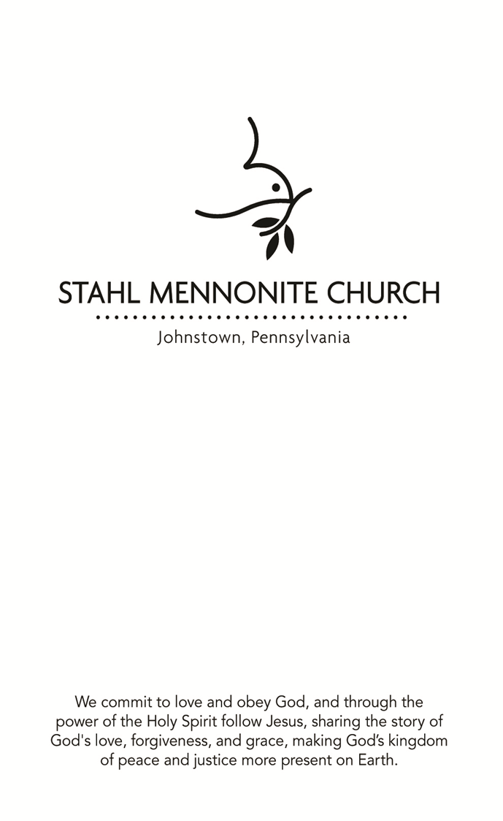

August 4, 2019
FOCUS STATEMENT: Practicing faith takes courage and
persistence. We all have a story to tell about how we
continue to walk this journey.

The Conemaugh Township Area Ministries Annual Picnic and Fellowship will be on Friday, Aug. 16, 6:00 p.m. at the Davidsville Community Church, 197 Pender Rd., Johnstown, PA. Tickets are $8 for adults and $4 for children under 12. For tickets call Nancy Gindlesperger at (814) 479-7458.

The Second Annual 814 Family Fun Day sponsored by Hope for Johnstown will be held at Roxbury Park on Sat., Aug. 17th from
12-6:00 p.m. Organizers are in need of help with registration, food prep, chaperoning a skating trip, or any other way you might assist. This is an opportunity to support the children and youth in the Greater Johnstown area. If you are interested or want more information, talk to Rachel Allen or see one of the following links: https://www.facebook.com/hope4johnstown/ or www.hope4johnstown.org

Marisa Smucker, who has been working for Mennonite Mission Network's Church Relations team, began serving as the Mennonite Voluntary Service program director in June. Pray that God will provide wisdom, energy and joy for Marisa as she serves in this capacity.

*****************PRAYER REQUESTS******************
Noah Cotchen Emily Kaltreider Kristin Kaltreider
Ray Gindlesperger Sandy Thomas Ruth & Jean Pierce
Dan Gates Shaun Smith Whitey Gindlesperger
Glenn Lehman Travelers Linda Gindlesperger
Norma Thomas Nancy Thomas Gary & Katie's Family
Wally Shank Myles' Friends Sarah Barrett's Family
Don & Grace Speigler Family (death)

The Conemaugh Township Area Ministries Annual Picnic and Fellowship will be on Friday, Aug. 16, 6:00 p.m. at the Davidsville Community Church, 197 Pender Rd., Johnstown, PA. Tickets are $8 for adults and $4 for children under 12. For tickets call Nancy Gindlesperger at (814) 479-7458.

The Second Annual 814 Family Fun Day sponsored by Hope for Johnstown will be held at Roxbury Park on Sat., Aug. 17th from
12-6:00 p.m. Organizers are in need of help with registration, food prep, chaperoning a skating trip, or any other way you might assist. This is an opportunity to support the children and youth in the Greater Johnstown area. If you are interested or want more information, talk to Rachel Allen or see one of the following links: https://www.facebook.com/hope4johnstown/ or www.hope4johnstown.org

Marisa Smucker, who has been working for Mennonite Mission Network's Church Relations team, began serving as the Mennonite Voluntary Service program director in June. Pray that God will provide wisdom, energy and joy for Marisa as she serves in this capacity.

*****************PRAYER REQUESTS******************
Noah Cotchen Emily Kaltreider Kristin Kaltreider
Ray Gindlesperger Sandy Thomas Ruth & Jean Pierce
Dan Gates Shaun Smith Whitey Gindlesperger
Glenn Lehman Travelers Linda Gindlesperger
Norma Thomas Nancy Thomas Gary & Katie's Family
Wally Shank Myles' Friends Sarah Barrett's Family
Don & Grace Speigler Family (death)

II Timothy 1:1-10
1Paul, an apostle of Christ Jesus by the will of God, for the sake of the promise of life that is in Christ Jesus,
2 To Timothy, my beloved child:
Grace, mercy, and peace from God the Father and Christ Jesus our Lord.
3 I am grateful to God—whom I worship with a clear conscience, as my ancestors did—when I remember you constantly in my prayers night and day. ⁴Recalling your tears, I long to see you so that I may be filled with joy. ⁵I am reminded of your sincere faith, a faith that lived first in your grandmother Lois and your mother Eunice and now, I am sure, lives in you. ⁶For this reason I remind you to rekindle the gift of God that is within you through the laying on of my hands; ⁷for God did not give us a spirit of cowardice, but rather a spirit of power and of love and of self-discipline.
8 Do not be ashamed, then, of the testimony about our Lord or of me his prisoner, but join with me in suffering for the gospel, relying on the power of God, ⁹who saved us and called us with a holy calling, not according to our works but according to his own purpose and grace. This grace was given to us in Christ Jesus before the ages began, ¹⁰but it has now been revealed through the appearing of our Savior Christ Jesus, who abolished death and brought life and immortality to light through the gospel.

II Timothy 1:1-10
1Paul, an apostle of Christ Jesus by the will of God, for the sake of the promise of life that is in Christ Jesus,
2 To Timothy, my beloved child:
Grace, mercy, and peace from God the Father and Christ Jesus our Lord.
3 I am grateful to God—whom I worship with a clear conscience, as my ancestors did—when I remember you constantly in my prayers night and day. ⁴Recalling your tears, I long to see you so that I may be filled with joy. ⁵I am reminded of your sincere faith, a faith that lived first in your grandmother Lois and your mother Eunice and now, I am sure, lives in you. ⁶For this reason I remind you to rekindle the gift of God that is within you through the laying on of my hands; ⁷for God did not give us a spirit of cowardice, but rather a spirit of power and of love and of self-discipline.
8 Do not be ashamed, then, of the testimony about our Lord or of me his prisoner, but join with me in suffering for the gospel, relying on the power of God, ⁹who saved us and called us with a holy calling, not according to our works but according to his own purpose and grace. This grace was given to us in Christ Jesus before the ages began, ¹⁰but it has now been revealed through the appearing of our Savior Christ Jesus, who abolished death and brought life and immortality to light through the gospel.

